# Time Series Stationarity Analysis

This document presents a program to check the stationarity of a time series dataset using rolling statistics (mean and standard deviation) and the Augmented Dickey-Fuller (ADF) test. A time series is considered stationary if its statistical properties, such as mean and variance, do not change over time.

## 1. Import Libraries

The following Python libraries are used:

- pandas: For handling the dataset.  
- matplotlib.pyplot: For plotting rolling statistics.  
- statsmodels.tsa.stattools.adfuller: For conducting the ADF test.

import pandas as pd  
import matplotlib.pyplot as plt  
from statsmodels.tsa.stattools import adfuller

## 2. Load the Dataset

The dataset is loaded from a CSV file and set up for analysis:

df = pd.read_csv('OzoneHole_Data.csv')  
df.set_index('Year', inplace=True)

## 3. Function to Check Stationarity

This function calculates and plots rolling statistics, and applies the ADF test:

def check_stationarity(timeseries, column_name):  
 rolling_mean = timeseries.rolling(window=5).mean()  
 rolling_std = timeseries.rolling(window=5).std()  
   
 # Plot rolling statistics  
 plt.figure(figsize=(10,5))  
 plt.plot(timeseries, label='Original Data')  
 plt.plot(rolling_mean, label='Rolling Mean', color='red')  
 plt.plot(rolling_std, label='Rolling Std Dev', color='black')  
 plt.legend()  
 plt.title(f'Rolling Statistics for {column_name}')  
 plt.show()  
   
 # Augmented Dickey-Fuller test  
 adf_test = adfuller(timeseries.dropna())  
 adf_output = {  
 'Test Statistic': adf_test[0],  
 'p-value': adf_test[1],  
 '# Lags Used': adf_test[2],  
 'Number of Observations Used': adf_test[3]  
 }  
 for key, value in adf_test[4].items():  
 adf_output[f'Critical Value ({key})'] = value  
   
 return adf_output

## 4. Execute the Stationarity Check

The stationarity check is performed on both 'Hole Area' and 'Minimum Ozone':

results_hole_area = check_stationarity(df['Hole Area'], 'Hole Area')  
results_min_ozone = check_stationarity(df['Minimum Ozone'], 'Minimum Ozone')

## 5. Results

The following graphs show the rolling statistics for both time series variables:

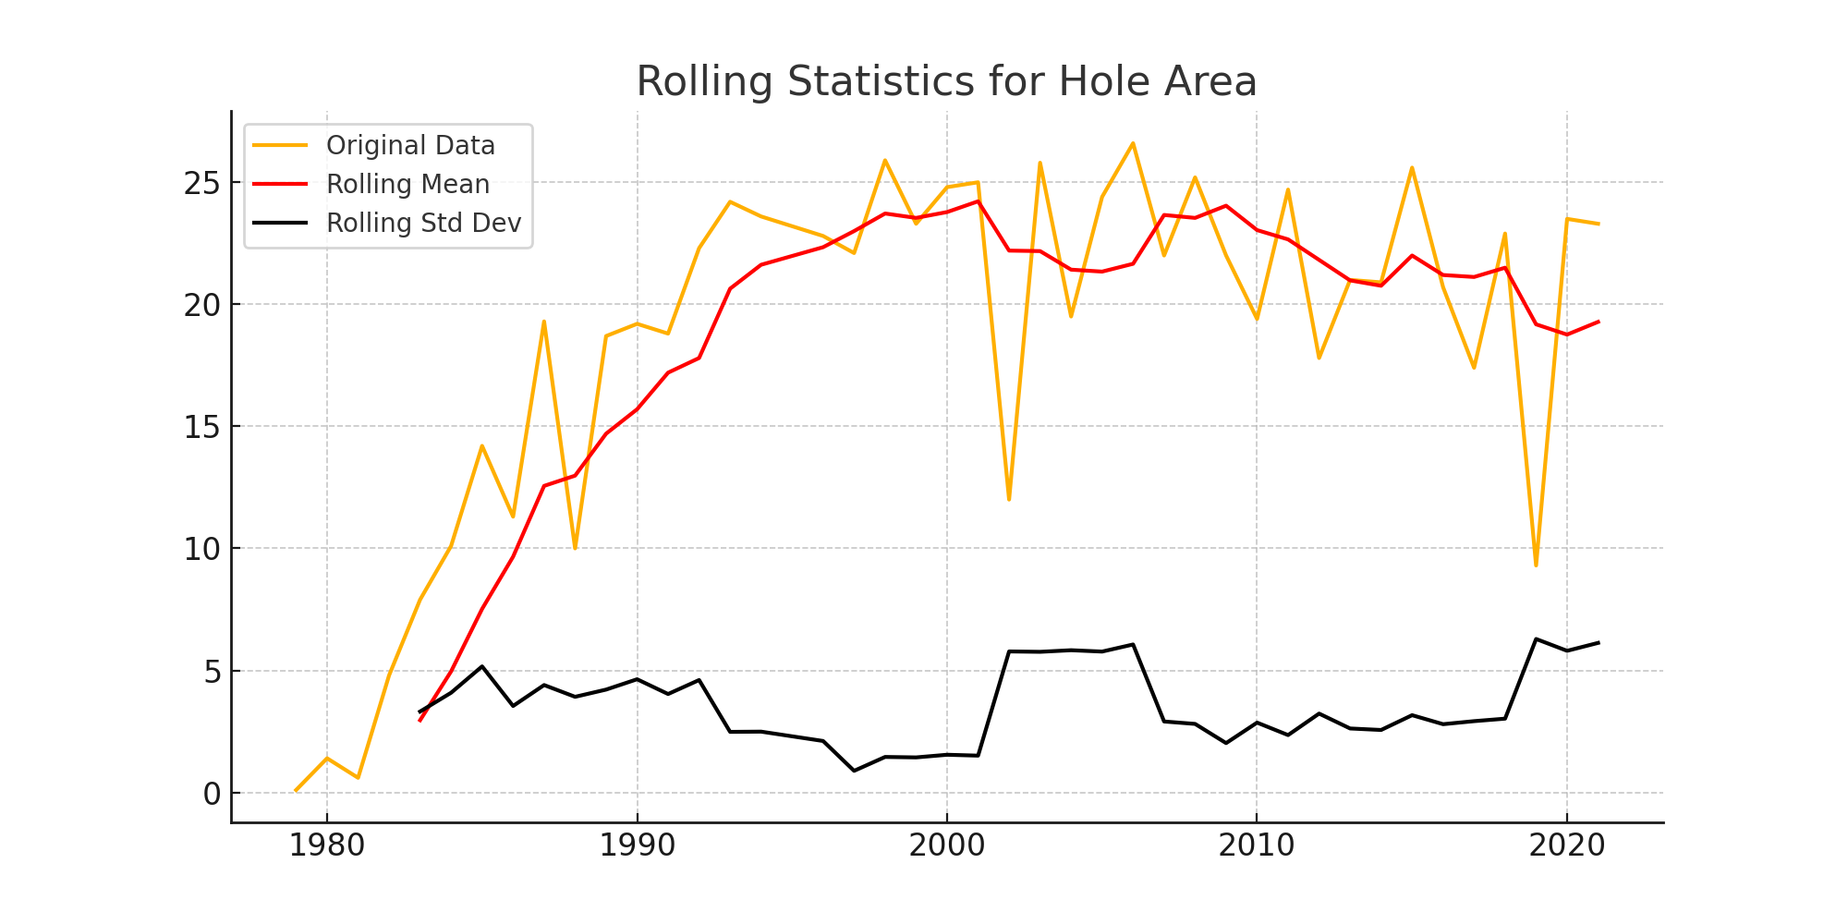

Figure 1: Rolling Statistics for Hole Area

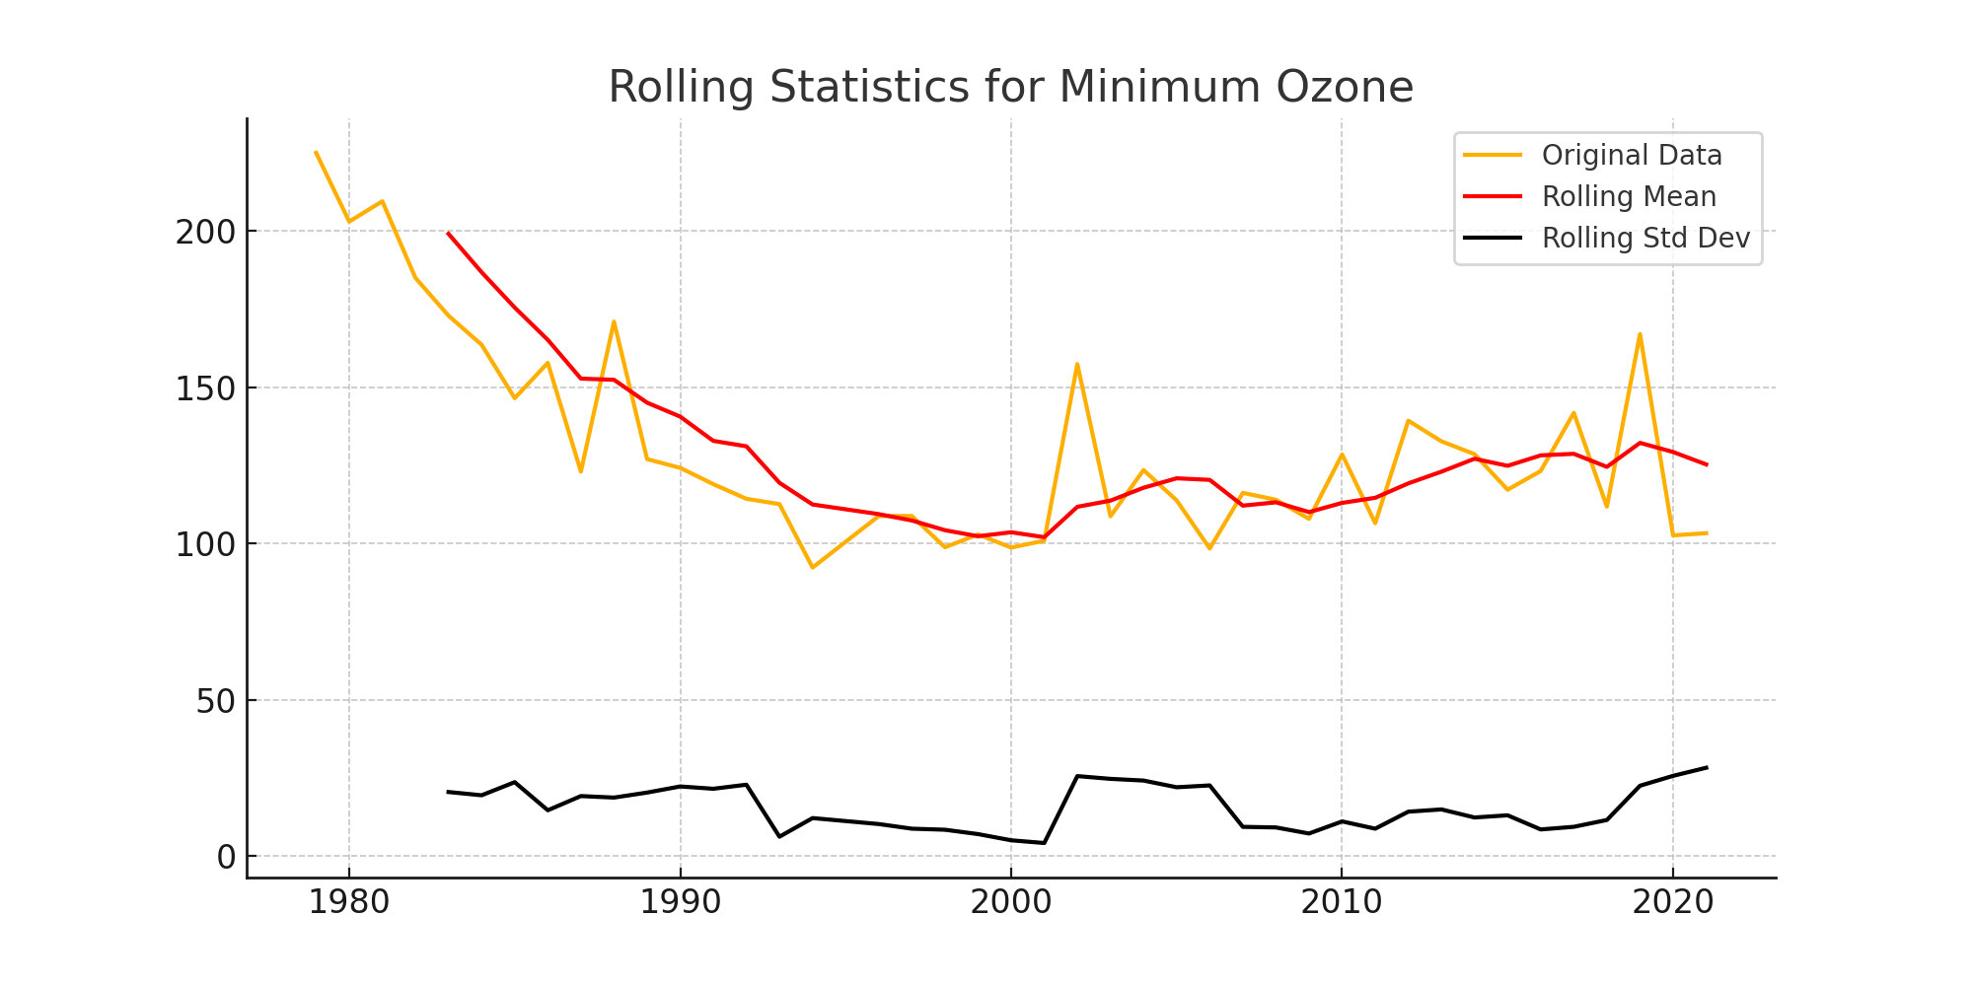

Figure 2: Rolling Statistics for Minimum Ozone

## 6. ADF Test Results

The Augmented Dickey-Fuller test results for both time series variables are as follows:

### Hole Area

Test Statistic: -3.4272088076880025

p-value: 0.010065565551098488

# Lags Used: 0

Number of Observations Used: 41

Critical Value (1%): -3.60098336718852

Critical Value (5%): -2.9351348158036012

Critical Value (10%): -2.6059629803688282

### Minimum Ozone

Test Statistic: -3.6781471668075967

p-value: 0.004431247406185966

# Lags Used: 0

Number of Observations Used: 41

Critical Value (1%): -3.60098336718852

Critical Value (5%): -2.9351348158036012

Critical Value (10%): -2.6059629803688282

## 7. Conclusion

The rolling mean and standard deviation help visually assess stationarity, while the Augmented Dickey-Fuller test provides statistical confirmation. Since both series have p-values below 0.05, we conclude that they are stationary.